LAB 15

Scenario
The IT Security manager has now tasked you, the only Threat hunter, with performing multiple hunts regarding WMI attacks, Parent Process spoofing and Access Token theft.
The hunts will be conducted against Windows, PowerShell, and Sysmon Events of an endpoint that was compromised during a Red Teaming engagement. The abovementioned attacks all took place on that endpoint.
Once you successfully conclude your hunts, you can inform the rest of the blue team about the "traces" these attacks leave behind so that they can also hunt for them.

Goals
The learning objective of this lab is increase familiarity of detecting common techniques utilized by attacks by doing a hands-on analysis.

What you will learn
You will learn how to utilize available logs to detect certain threats on a compromised host.

Recommended tools & Resources
- PowerShell
- Python
- https://attack.mitre.org/techniques/T1047/
- https://attack.mitre.org/techniques/T1502/
- https://attack.mitre.org/techniques/T1134/

Tasks

Task 1. Have malicious WMI commands been executed on the machine?
You were informed that the red team utilized WMImplant during the red teaming engagement.
Since this implant utilizes WMI, you should begin by hunting for WMI spawning suspicious processes (such as PowerShell). Then, utilize publicly available reports on WMImplant to identify more artifacts/traces this implant leaves behind. Such a report is the below. https://cyberwardog.blogspot.com/2017/03/chronicles-of-threat-hunter-hunting-for_26.html
Be reminded that this hunt will be based on the available Windows, PowerShell and Sysmon events of the compromised endpoint.
Once you are done with this hunt, you can inform the blue team so that they can proactively hunt for such malware from there on.

Task 2. Has Parent Process Spoofing occurred on the machine?
You were informed that the red team utilized the mspaint.exe process while attacking this endpoint. You were also informed that they tried to conceal their activities by employing an evasion technique known as Parent Process Spoofing.
You are tasked with hunting for Parent Process Spoofing against the mspaint.exe process.
Parent Process Spoofing will be analyzed thoroughly in another lab. For the time being focus on the below.
- 6/28/2022 11:53:08 AM - Sysmon EventID 1 related to mspaint.exe
- 6/28/2022 11:53:08 AM - Sysmon EventID 8 related to mspaint.exe

SOLUTIONS
Below, you can find solutions for each task. Remember though, that you can follow your own strategy, which may be different from the one explained in the following lab.

Task 1. Have malicious WMI commands been executed on the machine?
After reading technical reports (a.k.a tactical threat intelligence) on WMImplant, we can identify the below artifacts/traces.
- wmiprsve.exe spawning powershell.exe and probably executing obfuscated commands
- Environment Variable name on EIDs 12 and 13; Pattern: \\Environment\\[a-zA-Z0-9]{5}
- by PowerShell.exe
Now for our hunt, we can take an approach where we either group the indicators above, or we do a search based only on one of them. Since we are dealing with a single source of logs, we can take the second approach (this can be tedious though when dealing with big environments and multi terabytes of logs). Let's begin by the first indicator and check if any processes have been spawned by "wmiprsve.exe". To parse for that, run the following command (inside a PowerShell as an administrator terminal):
Get-WinEvent -FilterHashtable @{logname="Microsoft-Windows-Sysmon/Operational"; id=1} | Where-Object {$_.Properties[20].Value -like "*wmi*"} | fl
The output of the command contains only 1 result, which looks as follows:
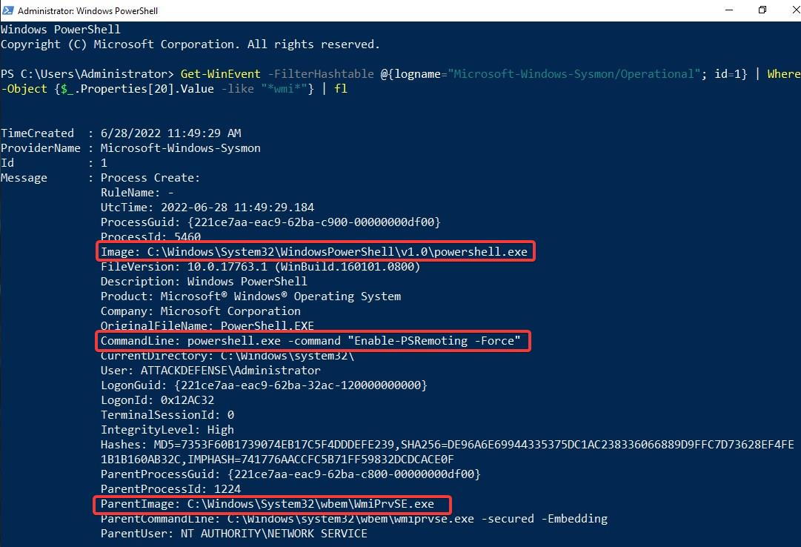
In fact, it appears that WmiPrvSE.exe has been executed on the machine, which spawns PowerShell with a command line parameter that aims to enable PowerShell Remoting.
We can "chain" that with Windows Security Logs, where we can see a login of the "Administrator" account from a remote machine with IP "13.229.91.59":
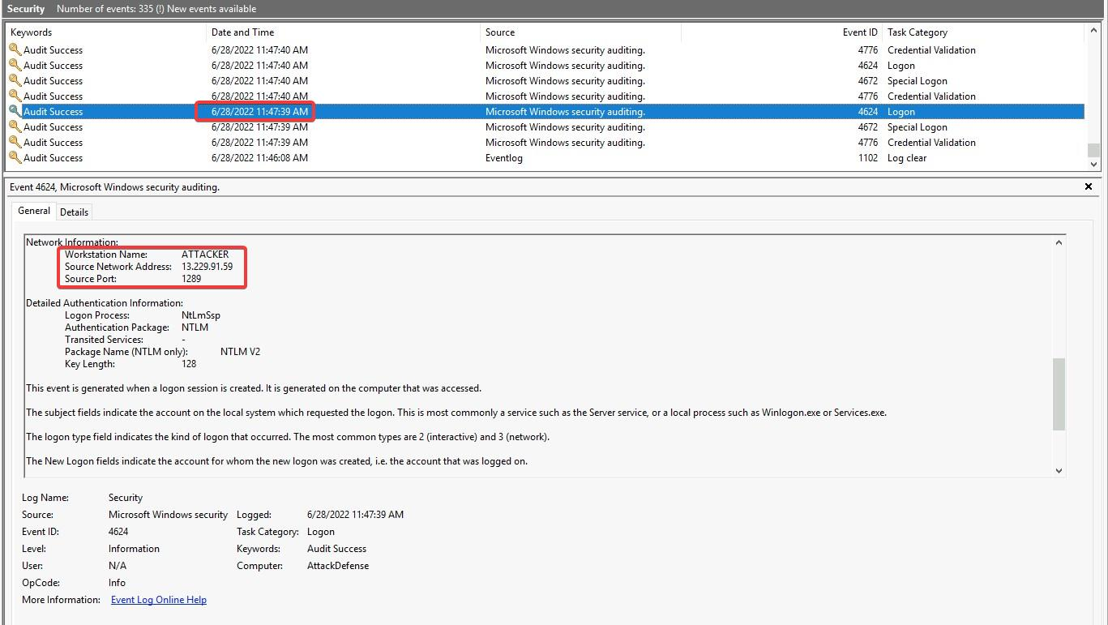
After which, the PowerShell Process is spawned:
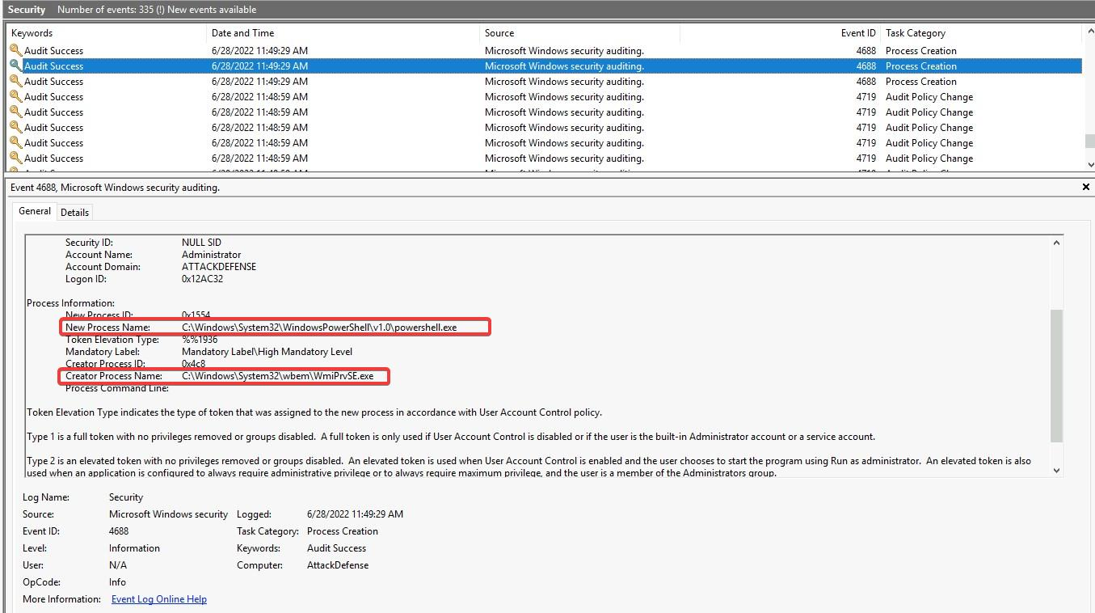
Note - If you look for other artifacts that we listed earlier, you may not find any of them because the red team did not utilize all of WMImplant's capabilities - perhaps all that was required was a single action enabling PSRemoting. We would have missed this if we had searched only for occurrence of, for example, 2 out of the 3 detection rules. Have this in mind during your hunts. Don't always search for multiple indicators at once!

Task 2. Has Parent Process Spoofing occurred on the machine?
By consulting with Sysmon's Process Creation logs or with the Security Process Creation logs, we can identify the following.
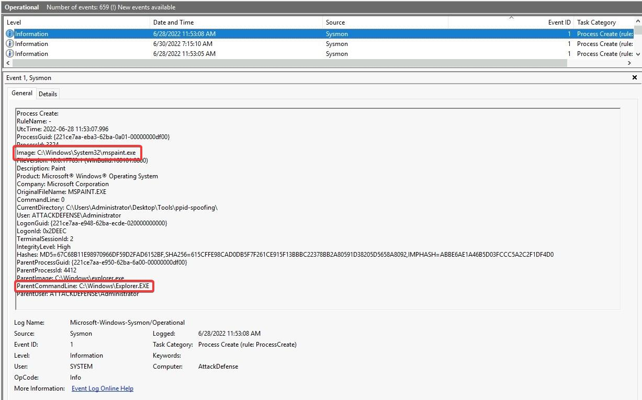
explorer.exe seems to be starting mspaint.exe. This looks quite natural, but an interesting event occurs immediately right after, where PowerShell creates a remote thread to mspaint.exe (which, to some extent, indicates that there is some kind of interaction between the 2 processes):
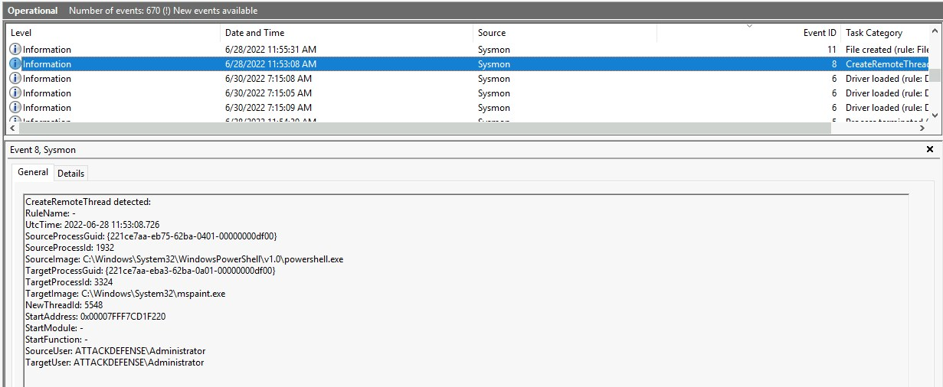

KEY TAKEWAYS
- Robust detection rules and non-default audit policies are required to perform high quality hunts
- Adversaries often choose to hide in plain sight
- Defender tools can be abused or disabled by attackers

